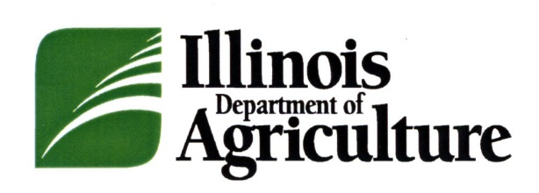

News
______________________________________________________________________________________
Philip Nelson, Director ● Bruce Rauner, Governor

FOR IMMEDIATE RELEASE CONTACTS:
April 23, 2015 Kristi Jones (217) 558-1546
Rebecca Clark (217) 785-5485

NORTH CLAY PACKING CO. RECALLS BRATWURST DUE TO MISBRANDING AND UNDECLARED ALLERGENS

SPRINGFIELD – North Clay Packing Co., an Illinois licensed establishment located in Louisville, IL, is recalling approximately 500 pounds of Bratwurst due to misbranding and undeclared allergens. The Illinois Department of Agriculture’s Meat and Poultry Inspection announced the recall today because the product contains milk, a known allergen, which is not declared on the product label.

The product subject to the recall was sold as white five pound boxes with plastic liners and labeled “ILLINI LAND BRATWURST”. The packaging bears the establishment number “476” inside the Illinois mark of inspection. The Bratwurst was produced on various dates from May 23, 2013 through September 3, 2014 and sold in Coles County.
IDOA discovered the potential health hazard during a routine inspection by meat and poultry inspectors. Neither the IDOA nor the company has received any reports of illness due to consumption of the recalled product. Anyone concerned about an injury or illness should contact a healthcare provider.
IDOA routinely conducts recall effectiveness checks to verify that recalling firms notify their customers of the recall and that steps are taken to make certain that recalled product is no longer available to consumers. When available, the retail distribution list(s) will be posted on the IDOA website at http://www.agr.state.il.us/recalls-and-public-health-alerts.
Consumers and reporters who have questions about the recall can contact the plant’s representative, Mike Frost, at (618) 665-3151.

###

