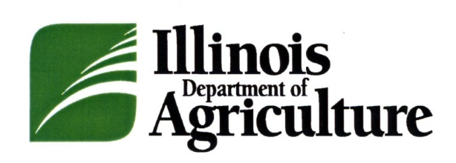

News
______________________________________________________________________________________
Philip Nelson, Director ● Bruce Rauner, Governor

FOR IMMEDIATE RELEASE CONTACTS:
April 8, 2015 Kristi Jones (217) 558-1546
Rebecca Clark (217) 785-5485

DOUGLAS COUNTY FOOD COMPANY RECALLS MEAT PRODUCTS DUE TO MISBRANDING AND UNDECLARED ALLERGENS

SPRINGFIELD – Dutch Valley Meats, an Illinois licensed establishment located in Arthur, is recalling approximately 2,400 pounds of “ham loaf” due to misbranding and undeclared allergens. Illinois Department of Agriculture (IDOA) Bureau of Meat and Poultry Inspection announced the recall today because the product contains wheat, a known allergen, which is not declared on the product label.

The product subject to the recall was sold as a two pound oven ready loaf in an aluminum pan wrapped with white butcher paper and labeled “HAM LOAF – OVEN READY.” The packaging bears the establishment number “326” inside the Illinois mark of inspection. The ham loafs were produced on various dates from April 1, 2013 through February 9, 2015 and sold in Douglas and Champaign counties to retail establishments.
IDOA discovered the potential health hazard during a routine inspection. Department meat and poultry inspectors determined the product was not properly labeled because the ingredients listed on the label did not include wheat, a known allergen.
Neither the IDOA nor the company has received any reports of illness due to consumption of the recalled product. Anyone concerned about an injury or illness should contact a healthcare provider.
IDOA routinely conducts recall effectiveness checks to verify that recalling firms notify their customers of the recall and that steps are taken to make certain that recalled product is no longer available to consumers. When available, the retail distribution list(s) will be posted on the IDOA website at http://www.agr.state.il.us/recalls-and-public-health-alerts.
Consumers and reporters who have questions about the recall can contact the plant’s representative, Loren Yoder, at (217) 543-3354.
###

