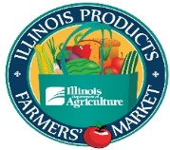
Illinois Product Farmers Market
“The Shed” / Illinois State Fairgrounds
Springfield, Illinois
3:30 p.m. – 7:00 p.m.
Every Thursday from May 18 – September 28, 2023
*The market will NOT be held on August 10th and August 17th (Illinois State Fair).
Dear Market Vendor,

It’s that time again! We are excited to get the 2023 Illinois Product Farmers Market underway.

All products sold at the Illinois Product Farmers Market must comply with local, state and/or federal health ordinances. The vendor must supply the correct documentation, licenses, certificates and permits listed below along with all their completed paperwork. Vendors must keep their license, permits, etc. current for the entire Market season. You will not be allowed to attend the market until your vendor guidelines and agreement has been signed by the Director of Agriculture and Legal and we have received all paperwork, licenses, certificates, permits, etc. Listed below are the forms and the documents (if applicable) you need to submit.
- Participation Form (Please make sure Name and Contact Information Match the Vendor Guidelines and Agreement)
- Vendor Guidelines and Agreement (Please make sure Name and Contact Information Match the Participation Form)
- Date Schedule
- Certificate of Liability Insurance – It is MANDATORY that the Illinois Department of Agriculture be listed as additional insured. Please add this terminology: “Illinois Department of Agriculture, it’s Officers, Agents, Directors, and Employees are additional insured.” to the Description of Operations.
- Illinois Product Farmers Market Link Benefits Form (if applicable)
- Illinois Product Farmers Market Link Match Benefits Form (If applicable)
- Copy of Illinois Department of Agriculture Meat & Poultry Broker License (if applicable)
- Copy of Illinois Department of Agriculture Egg Handlers License (if applicable)
- Copy of Illinois Department of Agriculture Feed Distribution & Manufacturing License (if applicable)
- Copy of Illinois Department of Agriculture-Nurserymen Certificate or Nurserymen License (if applicable)
- Copy of Sangamon County & State of Illinois Liquor Licenses (if applicable)

Checks should be made payable to the Agricultural Products Promotional Fund and mailed or take to the Illinois Department of Agriculture, c/o Nicole Moore, P.O. Box 19281, Springfield, IL 62794-9281. Online payment is accepted through: https://magic.collectorsolutions.com/magic-ui/en-US/Login/ill-agriculture and click on make a onetime payment. Select Bureau of Marketing in Payment Category and Marketing Event in Payment Type. Continue to complete the form and hit submit.

Please review everything carefully and submit all requested information and payment by March 31, 2023, to guarantee space availability, preferred spacing and location will be available on a first come basis. Mail the completed papers, documents, etc. and check made payable to the Agricultural Products Promotional Fund to Illinois Department of Agriculture, c/o Nicole Moore, P.O. Box 19281, Springfield, IL 62794-9281. A mandatory vendor meeting is scheduled for 5:00 p.m. on Tues, May 9, 2023, in The Shed, Illinois State Fairgrounds.
We look forward to your participation in making the market a success. Please contact our office if you need a vendor packet mailed to you.

If you have any questions, please contact me at agr.farmersmarket@illinois.gov or 217-524-9129. The best and quickest way to get ahold of me is through email.

Sincerely,
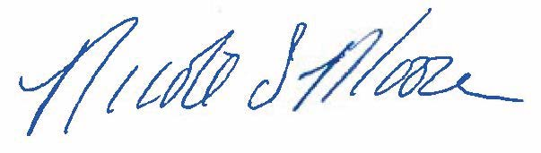
Nicole Moore
Market Manager
Illinois Department of Agriculture

