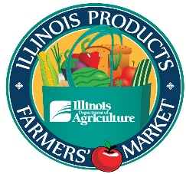
2023 Illinois Product Farmers Market
Vendor Checklist

- Participation Form (please enter the same name and contact information as the Vendor Guidelines and Agreement)

- Vendor Guidelines and Agreement (please enter the same name and contact information as the Participation Form)

- Certificate of Liability Insurance – There are Insurance Liability requirements, and it is mandatory that the Illinois Department of Agriculture be listed as additional insured.

- Date Schedule (mark dates plan to attend the Market)

- Illinois Product Farmers Market Link Benefits Form and/or Double Link Benefits Form (if applicable)

- Payment – Checks should be made payable to the Agricultural Products Promotional Fund and sent or taken to:
Illinois Department of Agriculture
Bureau of Marketing, Promotion & Grants
801 E. Sangamon Avenue
Springfield, IL 62702
Attn: Nicole Moore

Online –Online payment is accepted through: https://magic.collectorsolutions.com/magic-ui/en-US/Login/ill-agriculture and click on make a onetime payment. Select Bureau of Marketing in Payment Category and Marketing Event in Payment Type. Continue to complete the form and hit submit.

Questions?
Please call Nicole Moore at 217-524-9129
E-mail nicole.moore@illinois.gov

