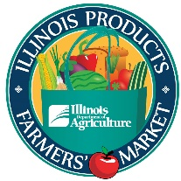
2023 Illinois Product Farmers Market
“The Shed” Illinois State Fairgrounds
Springfield, IL
May 18th through September 28, 2022

LIABILITY INSURANCE REQUIREMENT

Very Important!
You must obtain and show proof of liability insurance in the following minimum amounts: $100,000 per person; $300,000 per occurrence; and $100,000 property damage.

A Certificate of Insurance must be provided and kept on file by the IDOA from your company’s insurance agency. If you currently have a Certificate of Insurance for the Illinois State Fairgrounds, please provide us with a copy that states your policy term covers the dates of the Illinois Product Farmers Market. This information must be on the Certificate of Insurance: “The Illinois Department of Agriculture, its officers, agents, directors & employees are additional insured.”

The Certificate Holder should be listed as:

Certificate Holder:
IL Department of Agriculture
Bureau of Marketing, Promotion & Grants
801 E. Sangamon Avenue
Springfield, IL 62702

The IDOA must receive a copy of your Certificate of Insurance before you will be allowed to participate at the Market.

Please send a copy of your insurance certificate before your first date of participation in the Illinois Product Farmers Market.

If you have any questions, please call Nicole Moore at 217-524-9129.

Please return the certificate to: agr.farmersmarket@illinois.gov.

