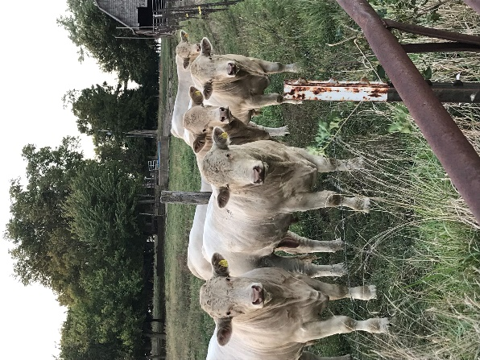
Illinois Premises Identification

Frequently Asked Questions

WHAT IS PREMISES REGISTRATION?
Premises identification numbers (PIN) are assigned to a unique geographic location where activity affecting the health and/or traceability of animals may occur. It is a unique seven-digit alpha numeric code to identify each location.

WHY IS PREMISES IDENTIFICATION IMPORTANT?
Premises identification is the foundation of developing and maintaining a system that can identify, within 48 hours, any animals or premises that have had direct contact with a disease of concern. This will help us to stop the spread of disease more quickly and reduce economic loss.

IS PREMISES ID MANDATORY?
No. Premises registration is a voluntary program for those who choose this level of protection for their operation. It may be required for participation in optional programs, for urban poultry producers, and to apply USDA official identification “840” tags.

Since comingling of animal species poses the greatest risk to our industries, many exhibition events and certain marketing channels encourage or require premises identification. For some food animal species, individual animal identification combined with premises registration is a valuable tool in meeting requirements for source verification and Country of Origin Labeling.

IS THERE A COST TO REGISTER?
There is no charge for premises registration.

WHO SHOULD REGISTER?
Anyone who keeps, houses or co-mingles livestock should register their premises.

HOW DO YOU DEFINE PREMISES?
Premises include: farms and hobby farms, backyard poultry owners, veterinary clinics, stables, livestock markets, livestock hauler and dealer premises where animals are kept, slaughter and rendering facilities, livestock exhibitions and any other location where livestock are kept. Producers should consider other facilities they own such as truck washes and feed mills.
WHAT INFORMATION IS COLLECTED?
The 911 address of all premises that house livestock as well as species type are necessary to establish a premises identification number. Additionally, the name, address and phone numbers of the primary and secondary contacts are critical to the goals of premises identification.

WHAT SPECIES ARE INCLUDED?
Bovine (bison and cattle), camelids (llamas, alpacas), captive cervidae (deer, elk, moose, caribou, reindeer and the subfamily musk deer), equine (horses, donkeys, zebras, and mules), goats, captive game birds (quail, pheasants, wild turkeys, and migratory waterfowl), poultry (commercial and backyard/hobby chickens, turkeys, geese, ducks and guinea fowl), ratites (rheas, ostriches, emu, cassowary, kiwi), rabbits, sheep and swine.

I HAVE MULTIPLE LOCATIONS. DO I REGISTER ALL OF THEM?
Every animal site that has a unique 911 address should have its own premises ID. Different numbers should also be issued for sites not contiguous with an operation. For example, a cattle farm may include a “primary” location and one or more “secondary” locations (such as a pasture). All separate locations should be registered. If there is no 911 address for a location, a latitude and longitude can be used in place of the address.

WHAT IF I ALREADY HAVE A SCRAPIE NUMBER?
Premises identification will not replace or alter your scrapie flock or tag numbers, so flock owners should still register their premises. Premises registration identifies land associated with livestock production. Multiple species of livestock may be identified at one geographical address. The USDA scrapie program and corresponding flock ID is for a specific flock.

ONCE I REGISTER MY PREMISES, DO I ALSO HAVE TO PARTICIPATE IN ANIMAL ID AND TRACKING?
No, a producer may register his/her premises only. While premises registration is the vital first phase in developing a trace back system, obtaining a PIN does not obligate you in any way. However, to purchase official “840” identification devices a producer must first register his/her premises. Identification via “840” devices is not mandatory.

HOW DO I REGISTER MY PREMISES IN ILLINOIS?
You may download the registration form located on our website here. Print or complete digitally and submit via email, mail or fax.
Mail: Illinois Department of Agriculture, Bureau of Animal Health and Welfare
801 E Sangamon Ave
Springfield, IL 62702
Email: AGR.PREMISES@illinois.gov
Fax: 217-558-6033
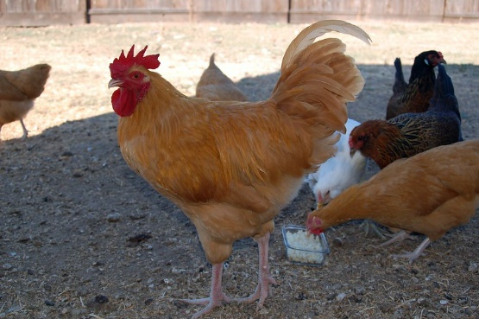
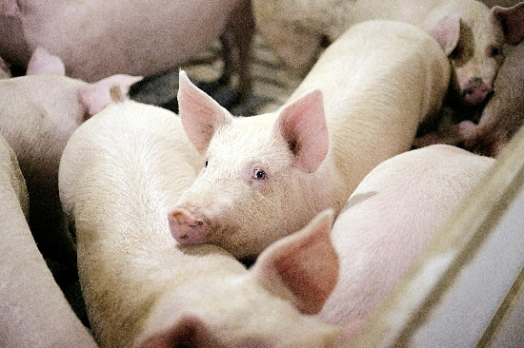
WHERE CAN I FIND MORE INFORMATION ON ANIMAL TRACEABILITY?
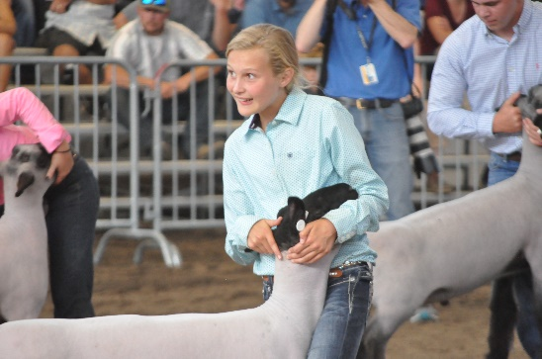
Additional information can be found on the USDA Animal Disease Traceability (ADT) website at https://www.aphis.usda.gov/aphis/ourfocus/animalhealth/SA_Traceability

