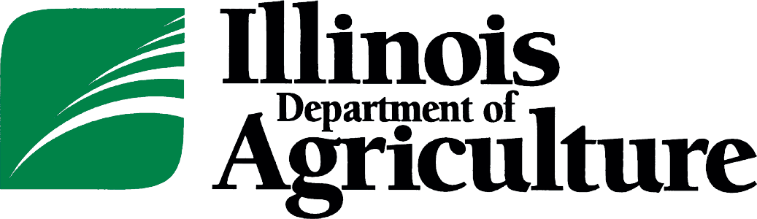
JB Pritzker, Governor
Jerry Costello II, Director

State Fairgrounds • P.O. Box 19281 • Springfield, IL 62794-9281 • 217/782-2172 • TTY 866/287-2999 • Fax 217/785-4505

Investment of Public Funds Report
For February, 2024

The Illinois Department of Agriculture (“Department”) is a State agency under the executive branch of the State of Illinois with such powers as enumerated in the Department of Agriculture Law (20 ILCS 205). The Department holds investments at State of Illinois chartered deposit institutions as operating accounts for various programs under the control of the Department.

This report is prepared solely to comply with the Accountability for the Investment of Public Funds Act (30 ILCS 237), and the information contained therein is not intended to be used for any other purpose. The information has not been subject to any audit and is not intended to be a presentation in conformity to Generally Accepted Accounting Principles.

As of 2/29/2024 the amounts held by the Department are: $2,707,860.

The asset allocation of the Department’s investments are:

Classification | Value | Yield | Percentage of Assets
Cash | 1,337,721 | 0.0000% | 49.40%
Illinois Funds LGIP* | 1,370,139 | 5.1572% | 50.60%

*Illinois Funds LGIP is a pooled investment portfolio operated by the Illinois State Treasurer. Further investment portfolio information can be found on the Illinois State Treasurer’s website: https://www.illinoistreasurer.gov/Local_Governments/The_Illinois_Funds

The total monthly investment income and yield for all funds invested by the Department for the month is $5,888.

The following is a list of all approved depository or investment institutions in which the Department currently holds assets:

Morton Bank
Illinois Funds (Illinois State Treasurer)
Banterra Bank

